**Big 5 Personality Factors: Factor Analysis WEEK 4  
By: Victoria Chung**

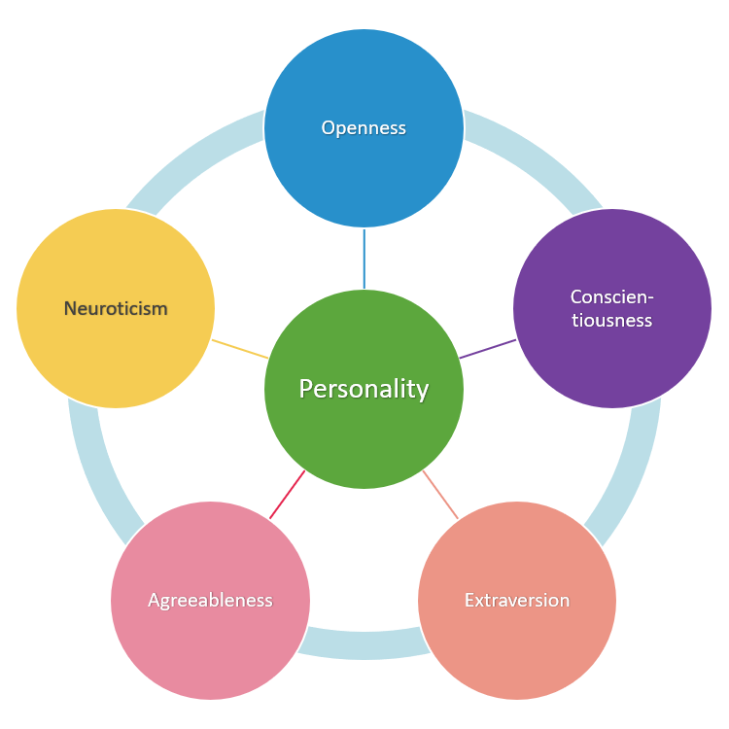

Factor analysis is a data reduction technique. It is commonly used to reduce a set of many individual items into a fewer number of dimensions or factors that can be used in further analysis. For instance, you may collect a variety of measures that relate to service aspects of your customers’ experience. Exploratory factor analysis (EFA) allows you to explore ways to reduce the large number of variables into a more simplified set of interpretable factors for further analysis. In this service survey example, you might be able to reduce a large number of questions into a few factors relating to the atmosphere/vibe, friendliness of staff, speed of service, and ease of finding answers. You may then collect a second sample (e.g. from another target market or geographic region) and use confirmatory factor analysis (CFA) to confirm that the factors seem to align in the same way as before. After you use factor analysis, you will still need to compute your factor scores, using the variables from your factor analysis (usually a simple average of the items selected), and check the Cronbach’s alpha. Doing the reliability analysis with Cronbach’s alpha also lets you double check that any items that needed to be reverse scored were properly handled before computing the factor score. Note that you do not need to reverse score items before doing an EFA.

For this assignment, we will use EFA and interpret the results. Note, that this is a rudimentary approach to confirming factor structure—in theory, you would use a more advanced form of structural equation modeling called confirmatory factor analysis to test fit of previously created factors. Before you begin this assignment, read **all** of the readings for Week 4 and watch the LinkedIn Learning videos. They will ensure that you are familiar with the Big 5 Personality Factors, what factor analysis is, how to interpret the findings, and some best practices for EFA.

***Part I: Initial Exploratory Factor Analysis (EFA)***

To begin, we are going to assume that we do not already know about the Big 5 personality factors. We have collected these sets of personality variables, and we want to explore what personality factors they represent using EFA. We also are going to assume that they may be correlated, as a starting point—so we will use Varimax rotation.

1. Download and open the “bif_factor analysis data” .sav file.
2. Analyze -> Dimension Reduction -> Factors
3. Dialog Box “Factor Analysis” pops up -> move variables A1 to O5 over into the “variables:” column
4. Click “Descriptives…” -> select “KMO and Bartlett’s test of sphericity -> “continue”
5. Click “Extraction…” -> select Principle Components -> click “scree plot” -> “continue”
6. Click “Rotation…” -> select “Varimax” continue”
7. Click “Ok” to run.
8. Answer the following, by typing your answer below each question:
   1. According to the KMO & Bartlett’s Tests, is factor analysis a useful method to approach this data? Explain why and report the test results.   
      Table

      Description automatically generated

Yes, the KMO & Bartlett’s tests are a useful method to approach this data. The KMO tells us whether we have enough data points to do the analysis. Since the KMO is at .849 and the result is greater than .05, we can continue using the data. This tells us we have enough data points and that we surveyed enough people.

The Bartlett test tests for significance to see if there is enough correlation between the 25 items to continue. We want the number to be less than .05 and since the significance is .000, we can continue. So, both results looks like we got enough data to do a factor analysis.

* 1. Using the Total Variance Explained table, Scree Plot, and Factor Matrix **to justify your response (use the data)**, how many factors do you think you would suggest?   
       
     Looking at the Total variance explained, scree plot, and factor matrix suggest there are a total of 6 factors. The Total Variance Explained below tells us not only are there 6 factors, but that the cumulative variance explained is 58.012. From the scree plot we can sort of see a break between 5 and 6 but we are not certain yet. The Rotated Component matrix also identifies the 6 columns for the 6 factors.

* 1. Refer to the Rotated Component Matrix.
     1. Remove any items that are cross loading or measuring nothing, or measuring something other than expected.

I have removed the following items A4, C3, N5, and O4 because the communality was not at least .5. I also removed E3 since it was measuring something other than expected.

* + 1. What do the negative factor loadings mean?  
       The negative factor loadings mean that test is going in the negative direction, you’re negatively correlated with the positive items. This is fine because there’s probably a reverse coded question.
  1. Re-run the Factor analysis. Notice it all works except for the Openness construct. Remove one of items in factor 6.  
     I have removed items Q2 and Q5 from the openness construct in factor 6.   
     Table

     Description automatically generated
  2. Re-run the analysis again. This should leave you with 5 factors

You can see through the Total variance explained and the Scree Plot that only 5 factors remain. You can also refer to the Rotated Component Matrix from 8D. You will notice that there is now only 5 columns.

* 1. Submit the Rotated Component Matrix with the items highlighted for each Factor with your write-up  
     Final results for the Rotated Component Matrix now align. We know now by certainty that these variables are being measured by these. Now our results are going to be clean there’s no confounding. We don’t have items that are not measuring anything or faking this out.   
     Table

     Description automatically generated

**IN CANVAS, you will submit ONLY 1 WORD DOCUMENT with your answers to the above questions. Please do not submit the SPSS.sav or SPSS output file.**